POI 2

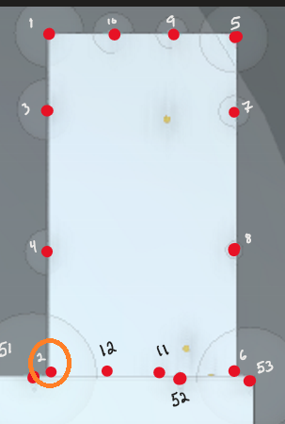



POI 2 pulls slope 0 resulting in incorrect multiplicative calculation.

POI 2 incorrectly reads not extended.

POI 6

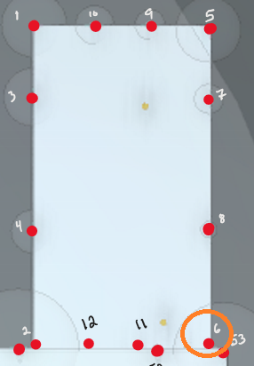

POI 6 incorrectly reads not extended.

POI 6 reads 0 slope.

POI 9-10:

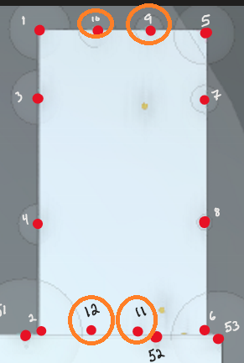

POI 9 pulls extended but does not pull a slope.



POI pulls extended but does not pull a slope

POI 11 & 12:

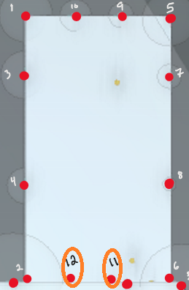

POI 11 pulls not extended correctly.

POI 11 pulls a slope of zero incorrectly.

Somehow this results in a NaN for multiplicative where a pitch of 0 should result in a Ki of 1.2424.

POI 12 pulls not extended correctly.

POI 12 pulls a slope of zero incorrectly.

Somehow this results in a NaN for multiplicative where a pitch of 0 should result in a Ki of 1.2424.

POI MAP:

